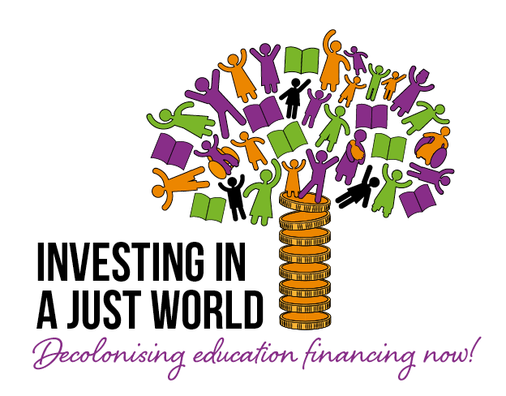
Letter to IMF Executive Director
Dear _____,
_____ is actively engaged in the Global Action Week for Education (GAWE) organised by the Global Campaign for Education. The GAWE2023 theme is Decolonising Education Financing so this might be a good opportunity to recall the key state obligations that international law contemplates regarding education financing and the role of international financial institutions.
The Universal Declaration of Human Rights (UDHR), the International Covenant on Economic, Social, and Cultural Rights (ICESCR), and the UN Convention on the Rights of the Child (CRC) reiterate the right to free and compulsory primary education and the right to an education that is universally available and progressively free at the secondary level. These international instruments also emphasise the right to lifelong learning from early childhood education to adulthood, the right to public quality education, and the right to education without discrimination that meets the needs of the most marginalised.
This makes it clear that:
- Education must be available and accessible to all;
- It must be provided free of charge and without discrimination.
- It must be of good quality, and
- it must promote social equality.
To meet these obligations, it is necessary for the government to take action to expand tax-to-GDP ratios through progressive tax reforms and to end austerity policies, particularly the use of public sector wage bill constraints that most acutely affect adequate education funding.
According to what is required by international human rights law, the austerity measures have proven to be a barrier that prevents the government from allocating the necessary budget for universally guaranteed education. Obviously, SDG 4 on quality education cannot be realised by 2030 without a significant and well-targeted increase in financing, particularly in those countries furthest from achieving quality education for all at all levels. Therefore, adherence to the international and regional benchmarks of allocating efficiently at least 4–6% of Gross Domestic Product and/or at least 15–20% of total public expenditure to education is very urgent.
It is well known that the World Bank and the International Monetary Fund are always in charge of such austerity measures.
To meet the sustainable development goal in education, at least 69 million additional teachers will be required by 2030, but current teachers around the world are struggling with low pay and unfavourable working conditions, which is lowering their status as a profession. There is a clear common cause uniting low pay and teacher shortages: both arise from decades of squeezed public funding, triggered most directly by the imposition of public sector wage bills constraints.
Whether imposed by the International Monetary Fund (IMF) or by Ministries of Finance that adhere to the same economic policy, public sector wage bill cuts and freezes have become a central flagship of wider austerity policies.
Teachers are the largest single group on most public sector payrolls, so constraints on the overall wage bill disproportionately impact teachers, pushing down their pay and blocking new recruitment. Instead, a government can choose to raise tax revenues progressively rather than cut spending. Indeed, the IMF estimates that most countries could increase their tax-to-GDP ratios by five percentage points between now and 2030.
We call upon you to analyse the financial situation facing our country so that the International Monetary Fund adopts bolder decisions, this time in line with the obligations established by international human rights law, and thus contributes to expanding tax revenues in progressive ways to finance education and other public services.
We will be happy to continue the dialogue with you.
In solidarity,
xx

