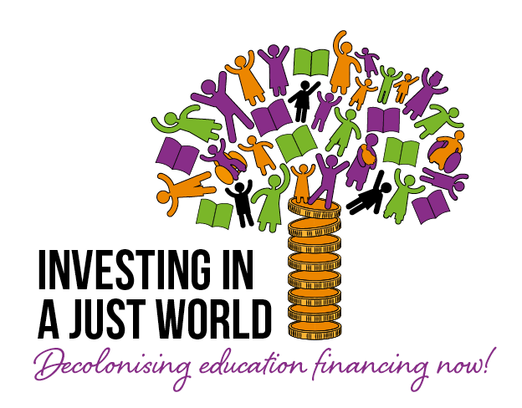
Letter to National Governments on Decolonising Education Financing
Dear _____,
_____ is actively engaged in the Global Action Week for Education (GAWE) organised by the Global Campaign for Education. The GAWE2023 theme is Decolonising Education Financing so this might be a good opportunity to recall the key state obligations that international law contemplates regarding education financing.
The Universal Declaration of Human Rights (UDHR), the International Covenant on Economic, Social, and Cultural Rights (ICESCR), and the UN Convention on the Rights of the Child (CRC) reiterate the right to free and compulsory primary education and the right to an education that is universally available and progressively free at the secondary level. These international instruments also emphasise the right to lifelong learning from early childhood education to adulthood, the right to public quality education, and the right to education without discrimination that meets the needs of the most marginalised.
This makes it clear that:
- Education must be available and accessible to all;
- It must be provided free of charge and without discrimination.
- It must be of good quality, and
- It must promote social equality.
In order to meet these obligations, it is necessary for the government to take action to expand tax-to-GDP ratios through progressive tax reforms and to end austerity policies, particularly the use of public sector wage bill constraints that most acutely affect adequate education funding.
We believe it is also necessary for the government to review the international financial and debt architecture to ensure sufficient financing can be mobilised in support of long-term, sustainable development objectives, including by removing conditionalities that require cutting expenditure on education as a prerequisite to attaining new financing and using innovative tools such as debt-for-education swaps.
We are aware that many obstacles to improving the financial situation—especially those that prevent the growth of the educational budget—are based on the imposition of international financial institutions. So, we ask your government to urge the International Monetary Fund (IMF), the World Bank, and other international financial institutions to remove existing austerity measures, recommendations, and obstacles such as public sector wage constraints that discourage increased spending on teacher salaries.
We reiterate to the government our willingness to cooperate in the fight for an adequate budget for education, and we respectfully remind you of the importance of committing to open up National and Education budget processes for public ownership, especially civil society participation, in budget making, budget monitoring, and budget review for enhanced inclusivity and accountability.
In solidarity,
xxx

