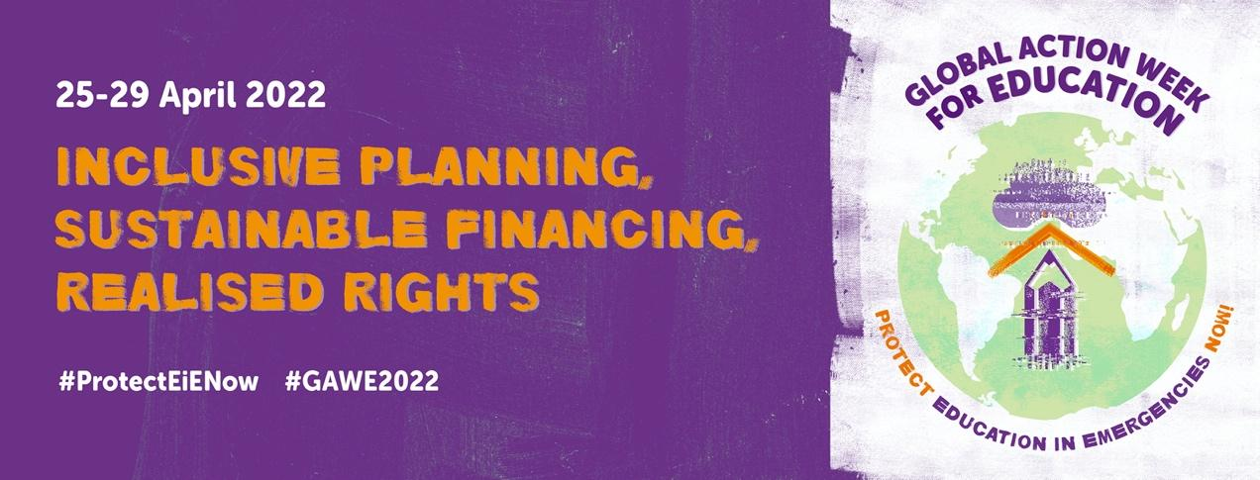

Please find included in this toolkit suggested social media posts to use during #GAWE2022 aligned with activities being undertaken by the GCE movement

DAY | TEXT | VISUAL  (Link to photo, film)
Countdown posts  (during week before GAWE) | Global Action Week for Education is back! It is time to take action for #Education in Emergencies! #GAWE2022 . Follow #GAWE2022 next week to #ProtectEiENow! https://bit.ly/3vNmVFx | 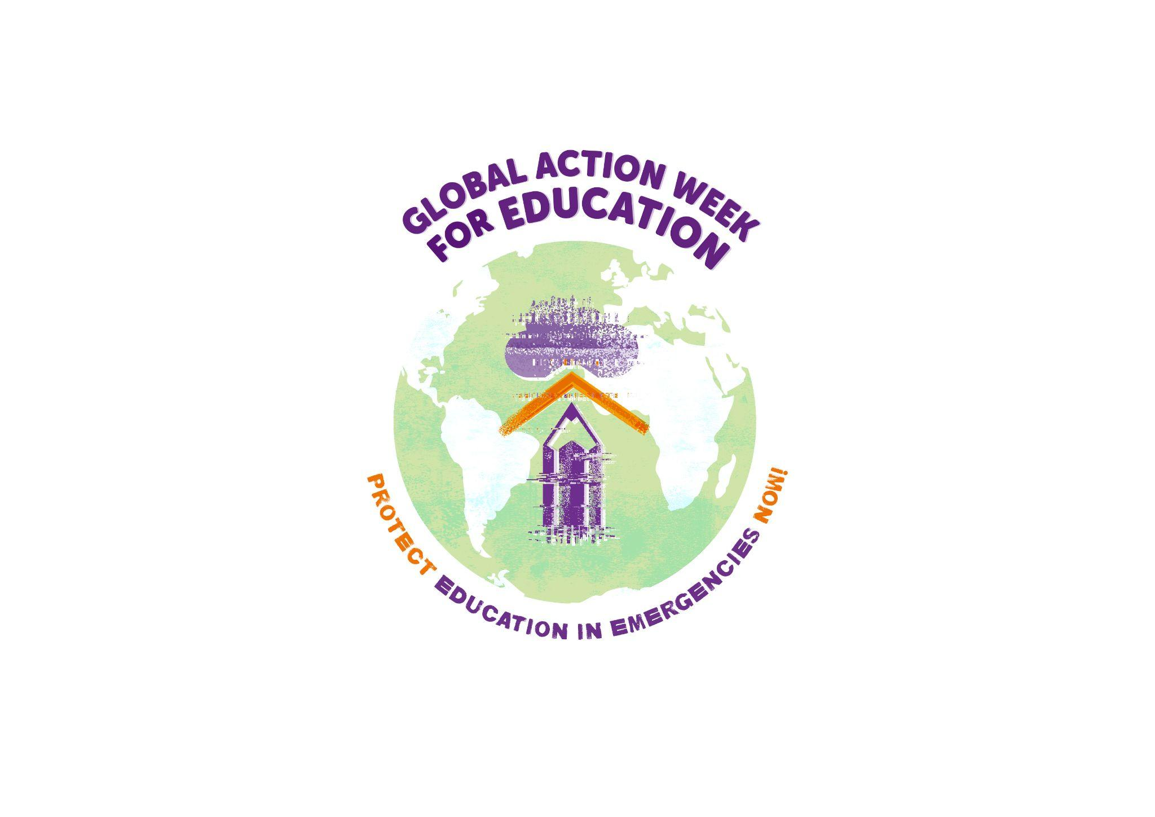  Countdown 10
16 April | We need the strength of Global Action Week for Education to tell world leaders it’s time to #ProtectEiENow! Follow #GAWE2022 next week and join the movement! | Countdown 9
17 April | This year’s Global Action Week for Education is a chance to stand together and call for urgent action for education in emergencies. Follow #GAWE2022 next week and find out how gvts, donors & civil society can #ProtectEiENow | Countdown 8
18 April | Join @ArabCampaignEdu  Mon. 25 April for 'GAWE 2022 ACEA Launch Event: Regional Policy Dialogue on Education in Emergencies in the Arab Region.'  📅 25 April ⏰ 15:00 CET  > RSVP at: https://bit.ly/3DlOHur  #GAWE2022 #ProtectEiENow | Countdown 7  OR  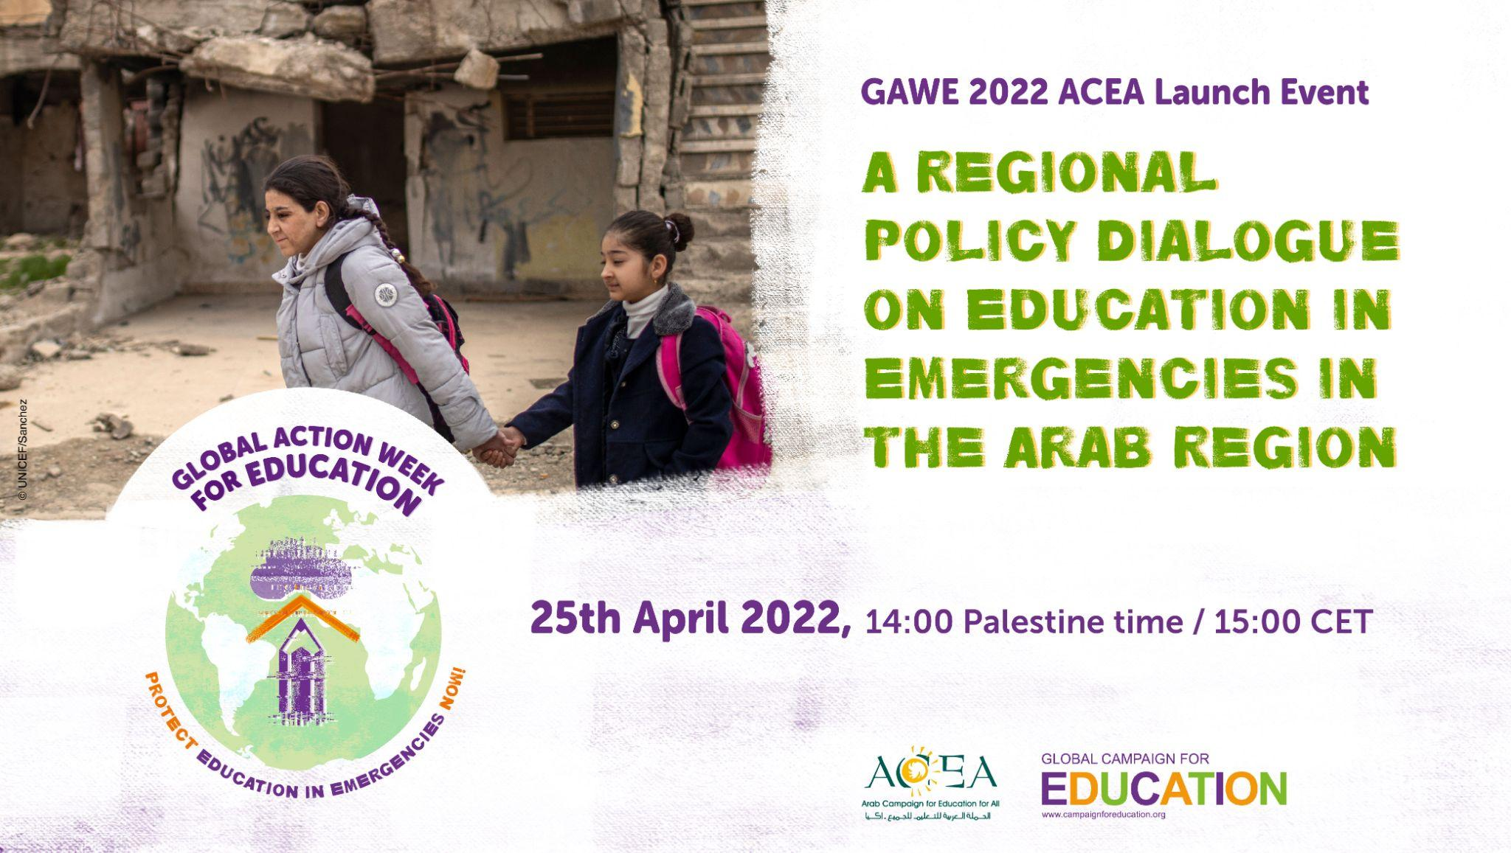
19 April | Join @redclade on Tue. 26 April for Education in emergency contexts in Latin America and The Caribbean: gender, debt & digitalization  📅 26 April ⏰ 10:00 EST/ 11:00 Brazil Time/ 16:00 CET 🔗https://bit.ly/GAWECLADE | Countdown 6  OR  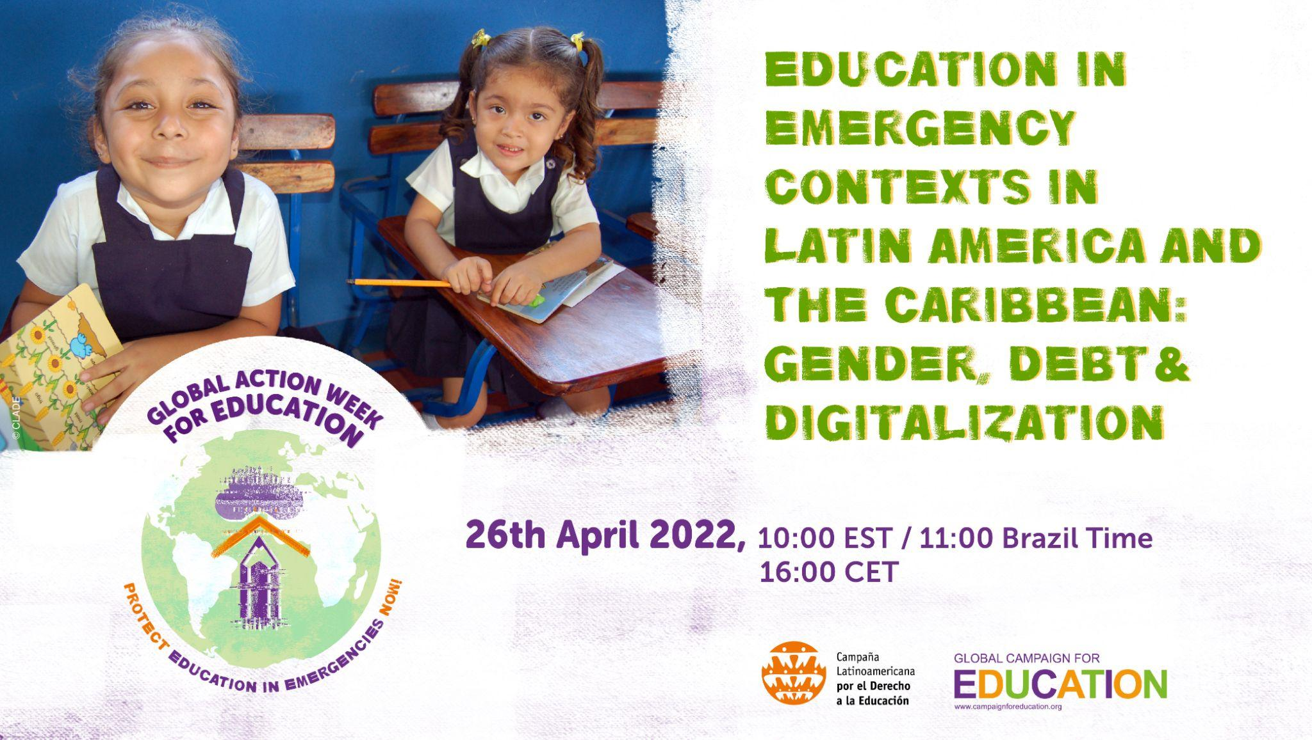
20 April | 📣 Tune in 📅 27 April ⏰ 13:00 Manila time / 7:00 CET  for @ASPBAE’s 'Protect Education in Emergencies Now: An Asia Pacific Regional Dialogue'  🔗https://bit.ly/aspbaegawe  # GAWE2022#ProtectEiENow | Countdown 5  OR  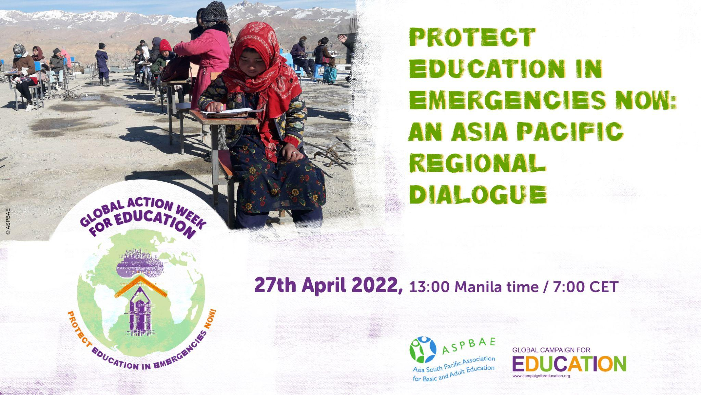
21 April | 📣 Register Now for 'Protecting Education in Emergencies. A Regional Policy Dialogue on Education in Emergencies in Africa' hosted by @AncefaRegional for #GAWE2022  📅 28 April  ⏰ 8:00 EST/ 12.00 GMT / 14:00 CET  🔗https://bit.ly/GAWEANCEFA  #ProtectEiENow | Countdown 4  OR  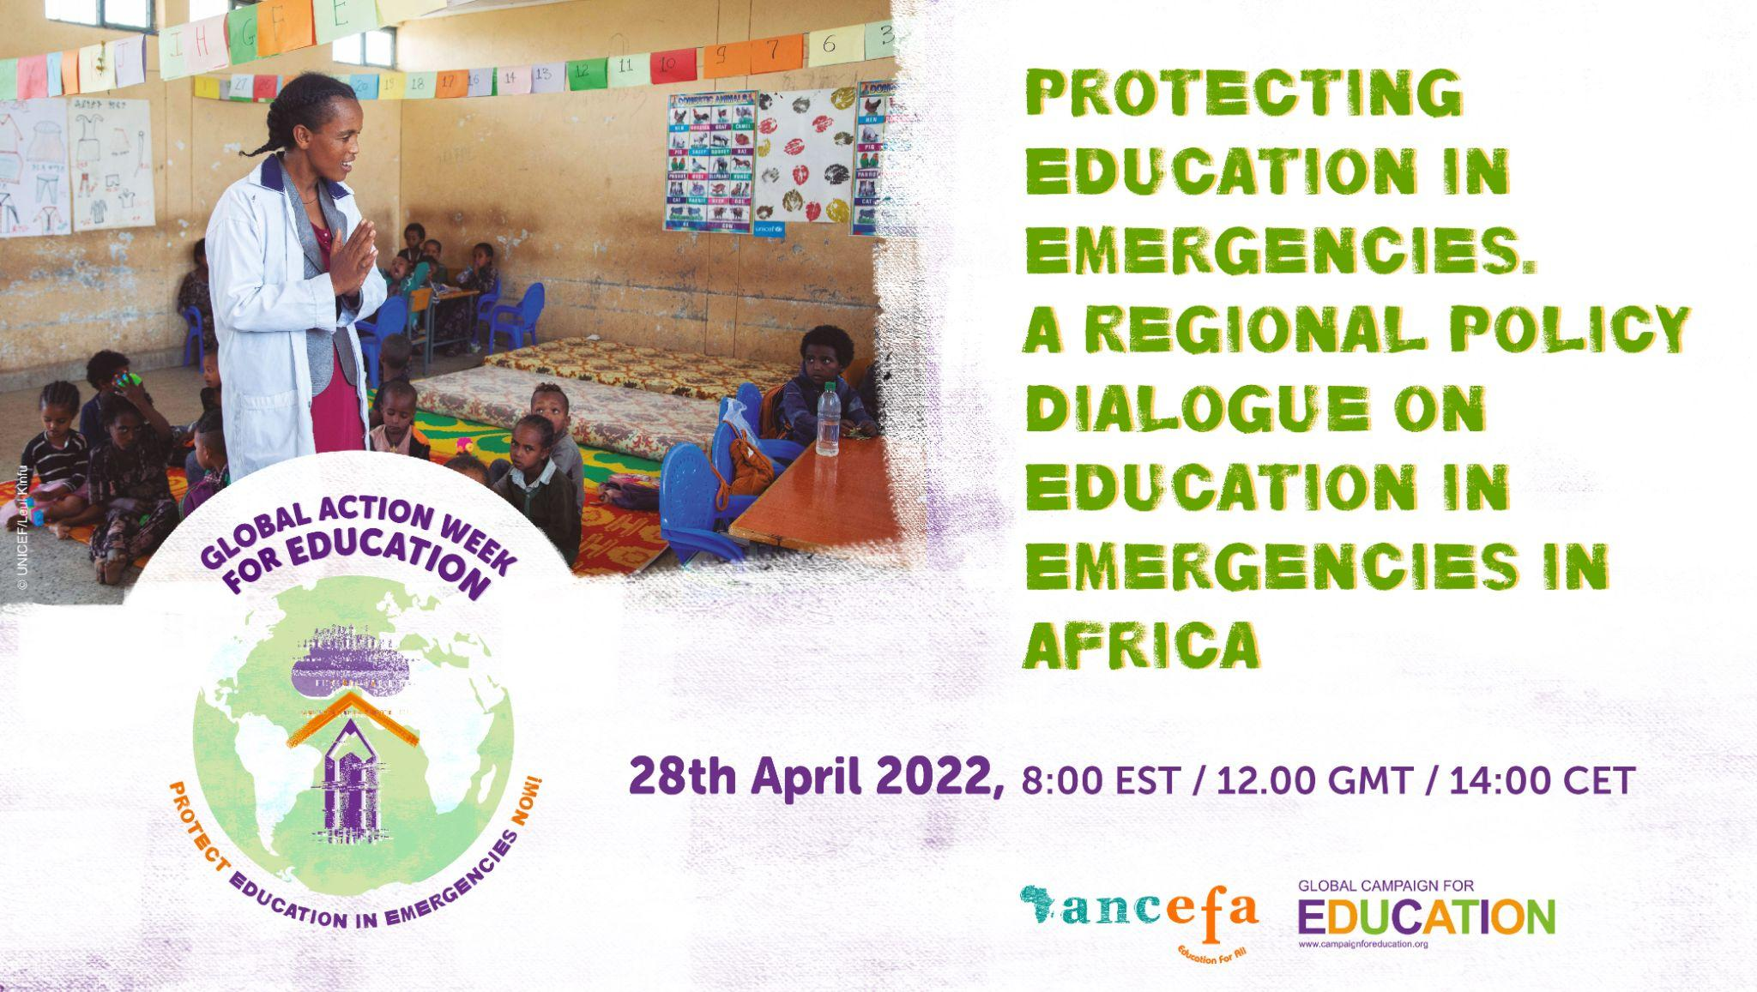
22 April | REGISTER NOW for #GAWE2022 Global Culmination Event: Equitable Access to Learning in Displacement: Taking Action Against Discrimination and Marginalisation  📅 29 April  ⏰ 8:00 EST / 14:00 CET  🔗https://bit.ly/GAWEGLOBAL  #ProtectEiENow | Countdown 3  OR  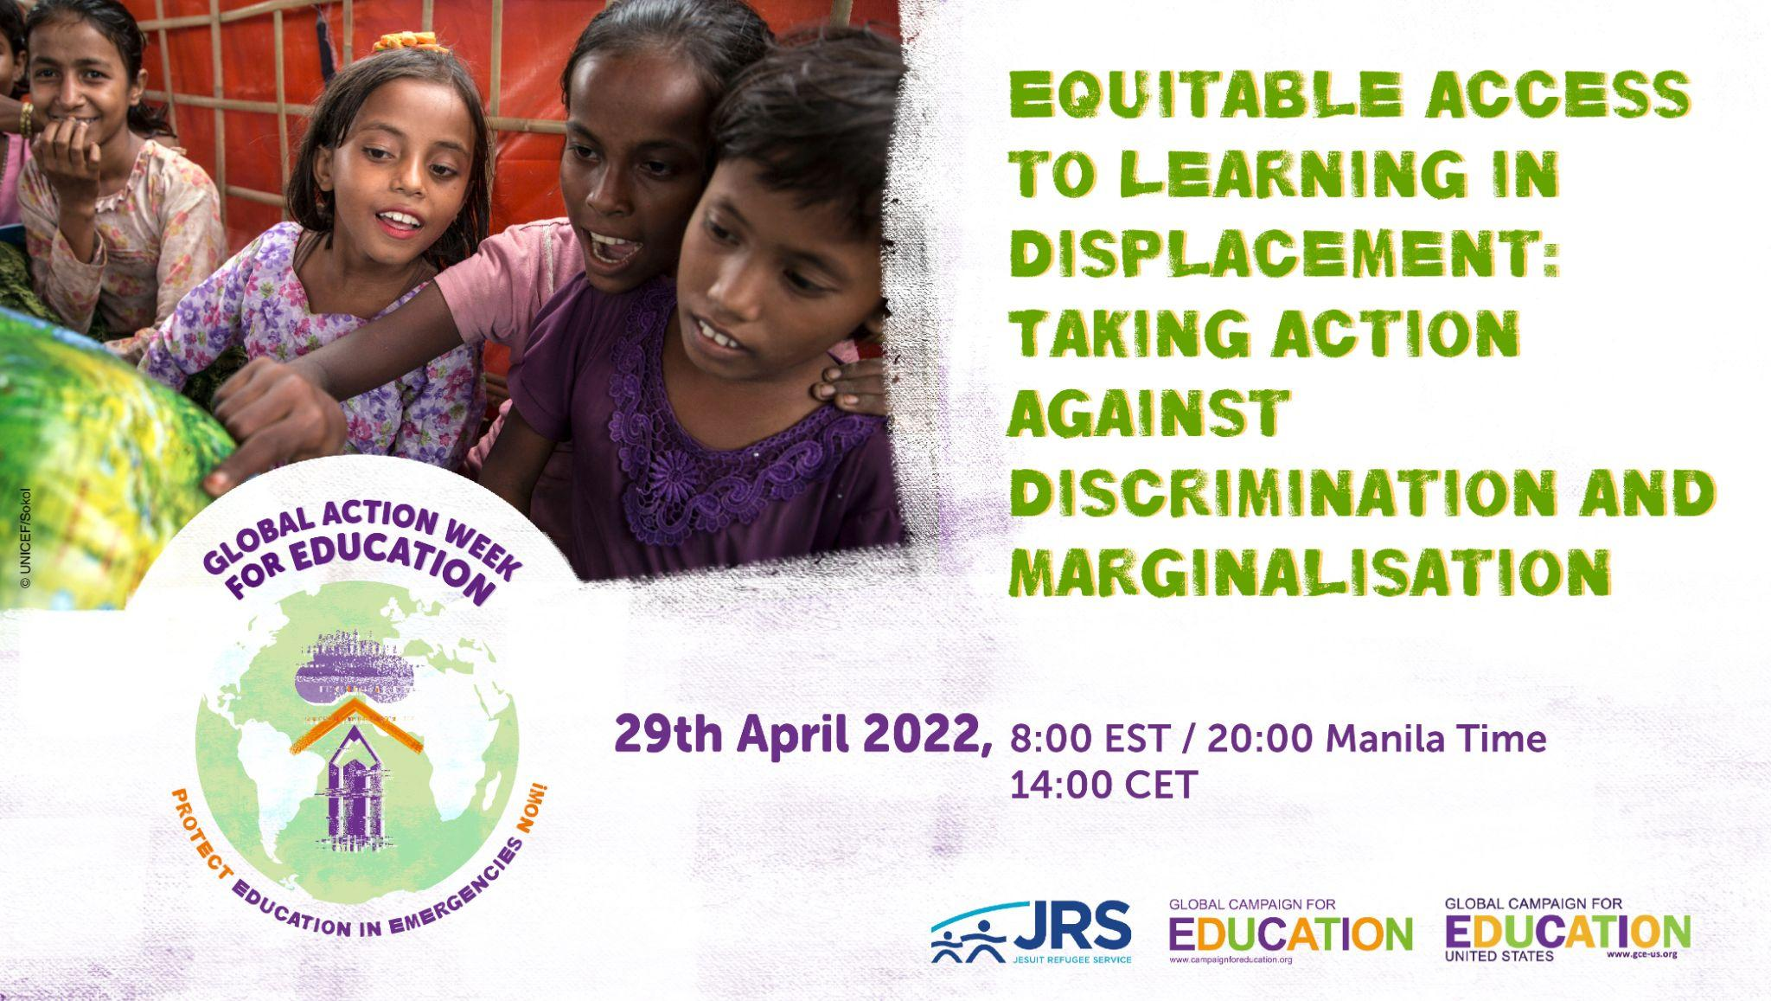
23 April | 📚✏️ 2 days to Global Action Week for Education! Follow #GAWE2022 next week to hear about the incredible work underway around the world to #ProtectEiENow @AncefaRegional @ArabCampaignEdu @ASPBAE @redclade @EduCannotWait | Countdown 2
24 April | Global Action Week for Education starts tomorrow! Join the global movement and demand urgent action for #education in emergencies now! #GAWE2022 #ProtectEiENow | Countdown 1
Mon 25 April | 📚✏️ It is Global Action Week for Education! Follow us all week to hear about the incredible work underway around the world to #ProtectEiENow #GAWE2022 @AncefaRegional @ArabCampaignEdu @ASPBAE @redclade
Today #GAWE2022 focuses on the impact of conflicts on the right to education in the Arab Region. Join @ArabCampaignEdu’s Launch Event: Regional Policy Dialogue on Education in Emergencies in the Arab Region.'
📅 25 April ⏰ 15:00 CET
🔗 https://bit.ly/3DlOHur
#ProtectEiENow
 | Political instability & conflicts are keeping 16 million children out of school in the Arab Region. With  @ArabCampaignEdu we call on  @arableague_gs, @G7 @WorldBank  @IFC_org and @UN agencies to take all measures to ensure their enrolment in compulsory primary  education #GAWE2022 | 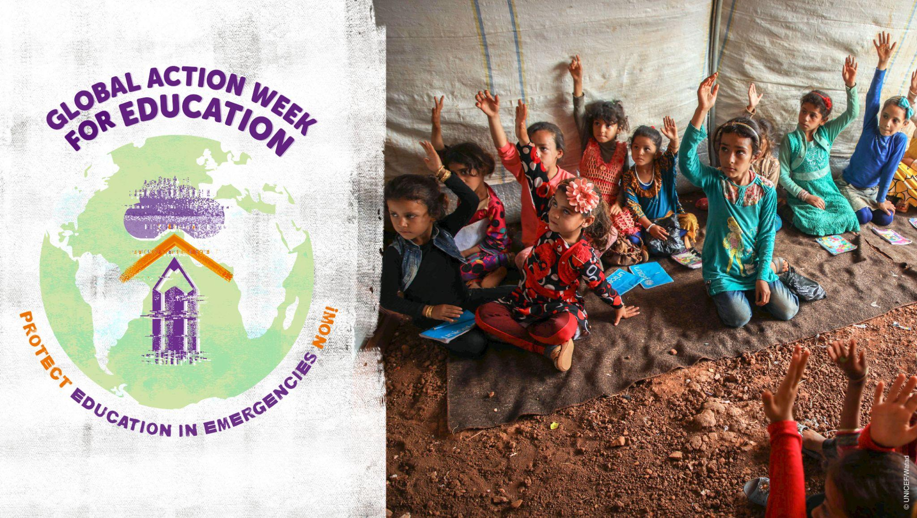
 | Together with @ArabCampaignEdu we call on  @arableague_gs @G7 @WorldBank  @IFC_org and @UN agencies to  #ProtectEiENow & provide the funding to restore & rebuild +2,500 schools in #Yemen, about 489 schools in #Libya, and hundreds of schools in #Syria and the #Gaza Strip.  #GAWE2022 | 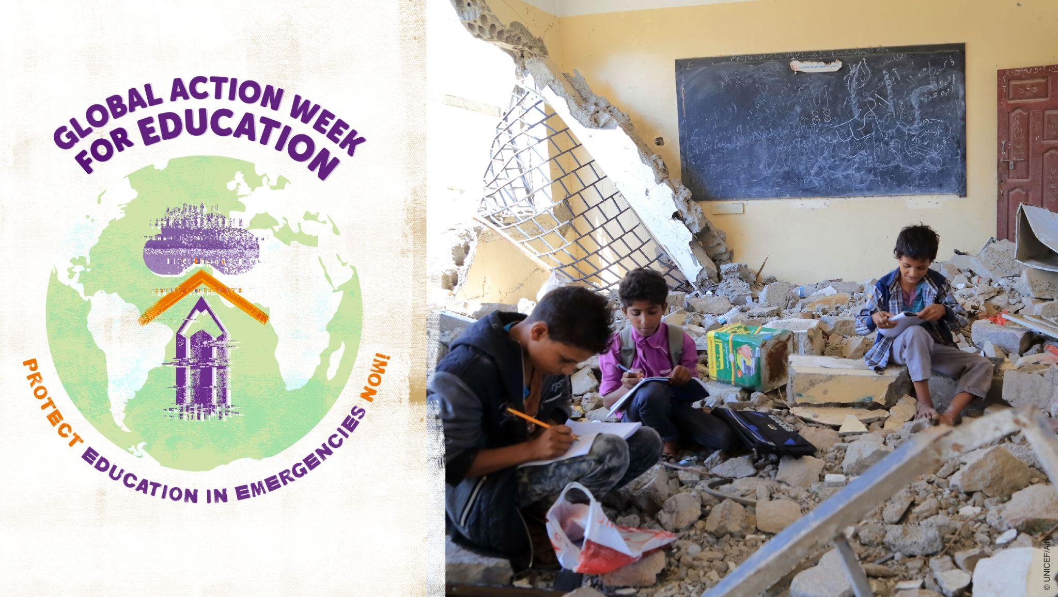
 | Short text:  Gvts in the Arab Region & @arableague_gs must  #ProtectEiENow by providing appropriate infrastructure & technology for learners, psychosocial support & training for education personnel and by involving local communities in educational planning and curriculum development.  #GAWE2022  Short text:  Governments in the Arab Region must adhere to minimum standards for  #education in times of crisis and  #ProtectEiENow by providing appropriate infrastructure and technology for learners, psychosocial  support & training for education personnel and by involving local communities in educational  planning and curriculum development. | 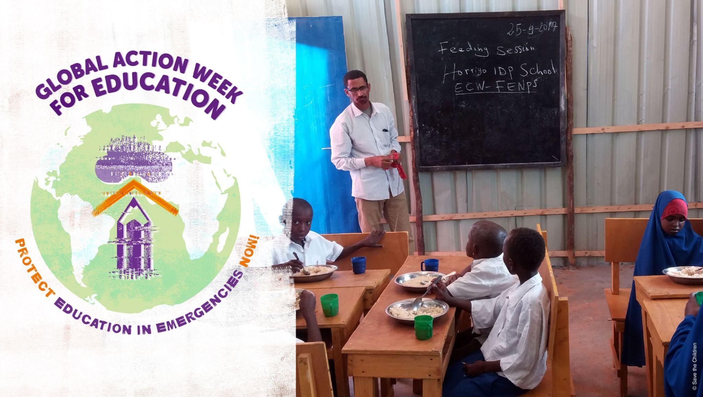
Tues 26 April | Today #GAWE2022 focuses on Latin America & the Caribbean and @redclade are hosting an event to discuss 'Education in emergency contexts in Latin America and the Caribbean: gender, debt & digitalization' Tune in!  📅 26 April ⏰ 10:00 EST/ 16:00 CET  🔗https://bit.ly/GAWECLADE  #ProtectEiENow
 | Inclusive and gender-sensitive education is essential in emergency contexts and key to overcoming social inequalities. #ProtectEiENow #GAWE2022 @redclade | 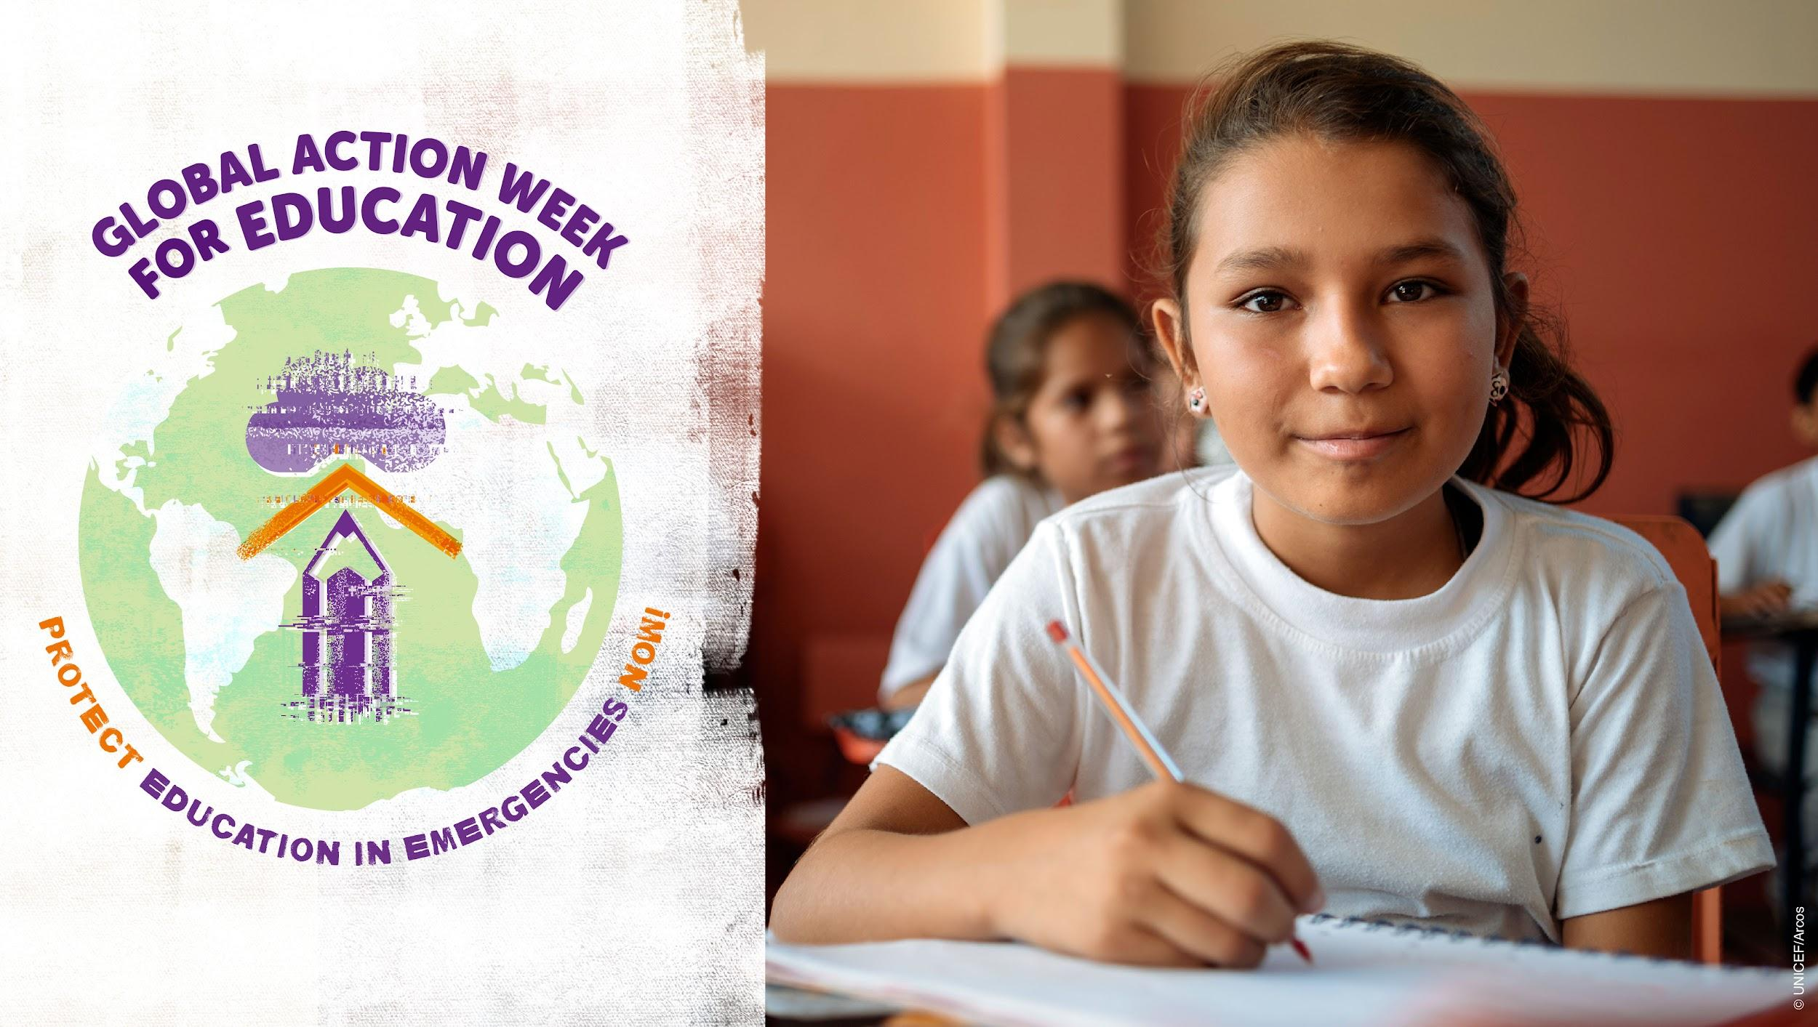
 | #EducationInEmergencies: Public funding is essential to guarantee public and free #education including in emergencies! #ProtectEiENow #GAWE2022 @redclade | 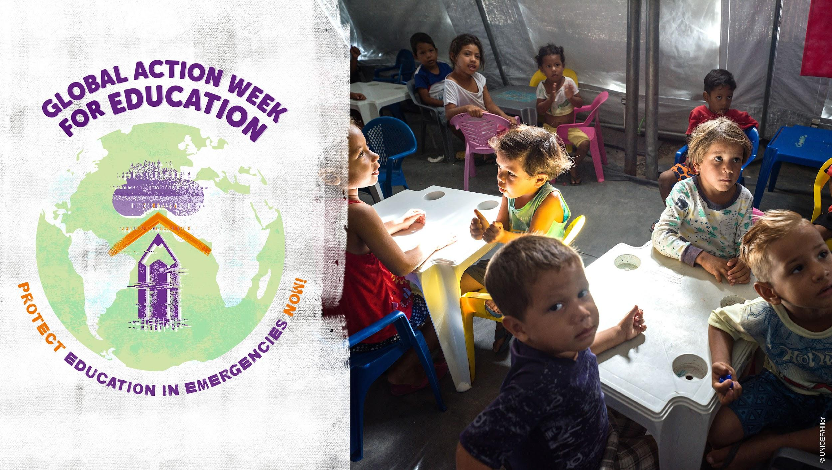
 | Inclusive education requires digital rights, especially during emergencies! #ProtectEiENow #GAWE2022 @redclade | 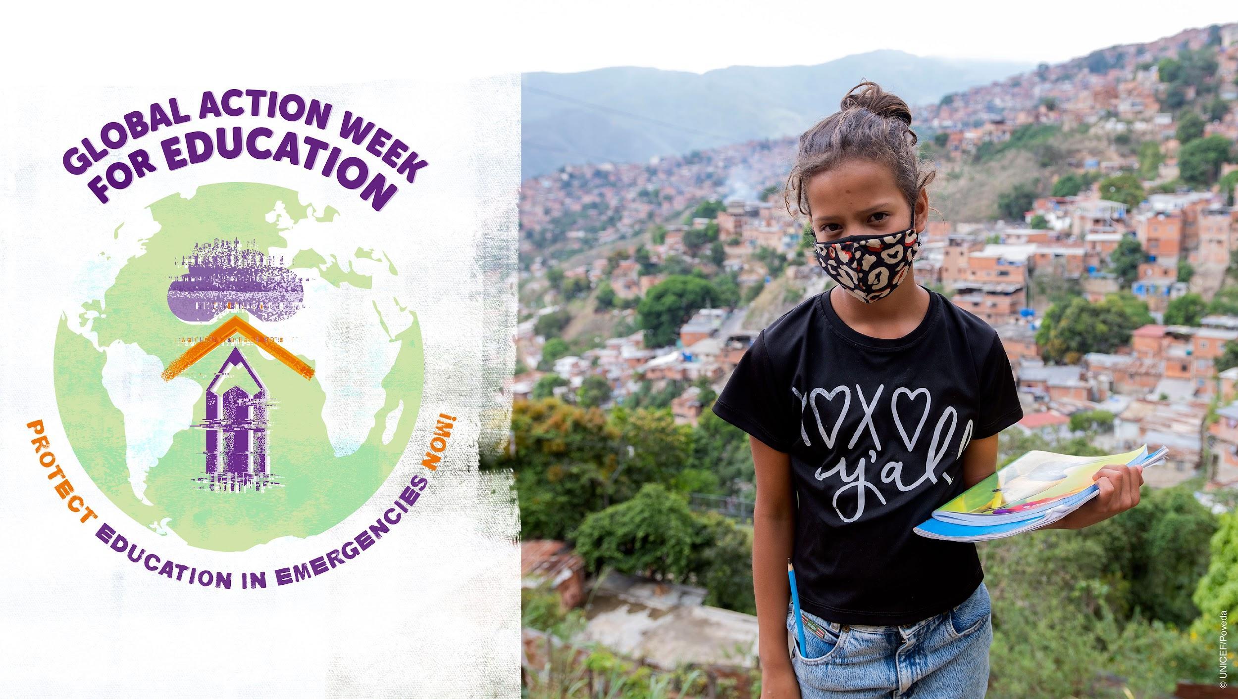
Weds 27 April | Today we focus on #Asia & the #Pacific and @ASPBAE are hosting:  'Protect Education in Emergencies Now: An Asia Pacific Regional Dialogue'  📣 Tune in 📅 27 April ⏰ 13:00 Manila time / 7:00 CET  🔗https://bit.ly/aspbaegawe  #GAWE2022 #ProtectEiENow
 | Today we join forces with @ASPBAE to call on all stakeholders involved in emergency response to #ProtectEiENow and ensure access to quality and safe #education in emergencies for #women & #girls and youth & adults. #GAWE2022 | 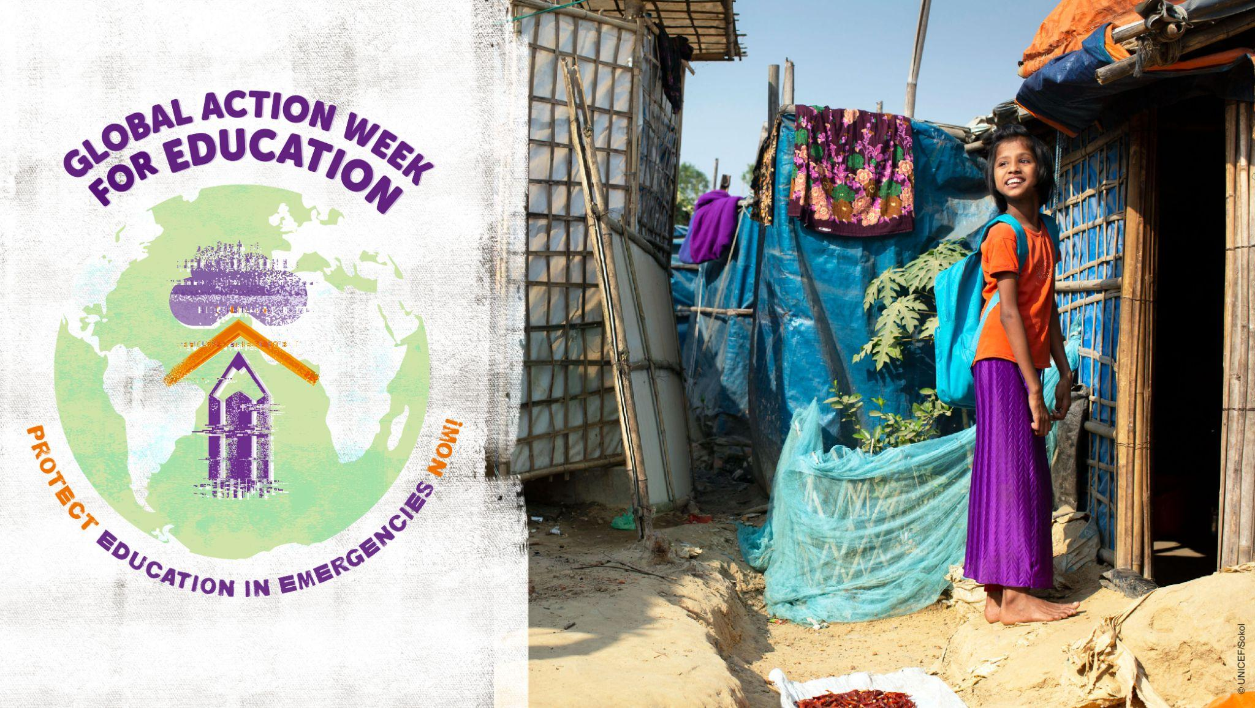
 | Together with @ASPBAE we call on Governments and donors to increase national education budgets to #ProtectEiENow !  #GAWE2022 | 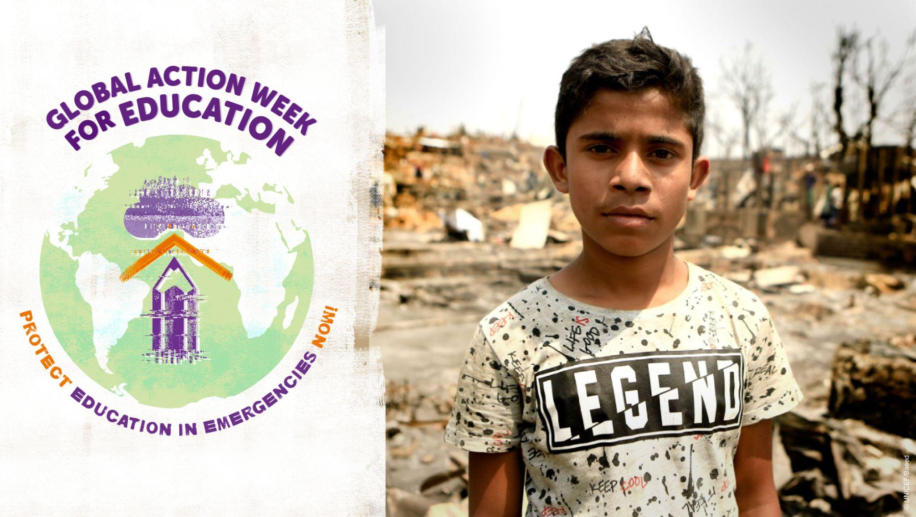
 | This #GAWE2022 together with @ASPABE we call on governments in the Asia-Pacific region and beyond to ensure that #education systems integrate disaster risk reduction management and the recording and monitoring of the impact of disasters on #education #ProtectEiENow | 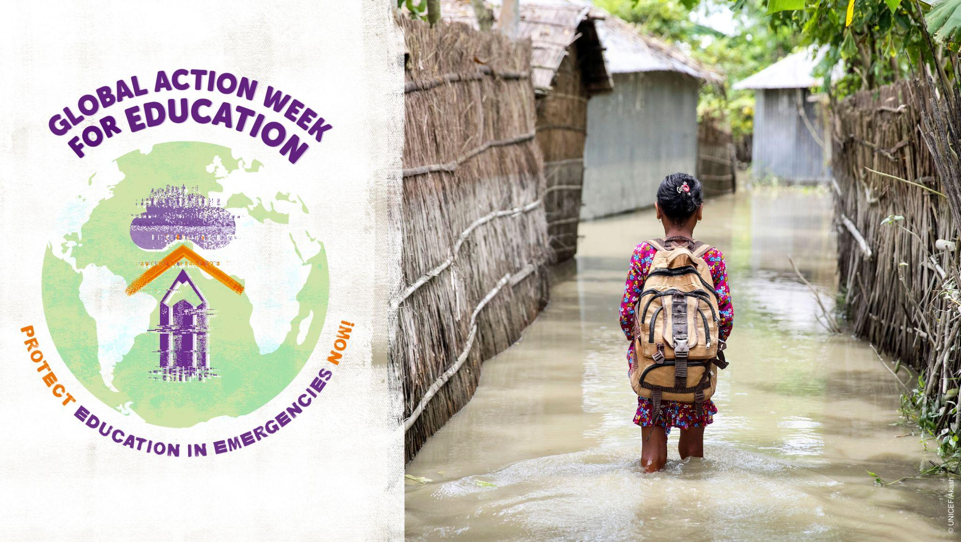
Thurs 28 April | Today we focus on Africa! Join @AncefaRegional 's #GAWE2022 event to discuss how to #ProtectEiENow in contexts of conflict and terrorism.  📅 28 April  ⏰ CET 14:00  🔗🔗https://bit.ly/GAWEANCEFA
 | In 2021, a spike in attacks in Central Sahel forced 5500 schools to close & deprived 1 million learners from their right to #education. @AncefaRegional calls on the @_AfricanUnion @ecowas_cedeao & @G5_Sahel_SE to #ProtectEiENow & implement the #SafeSchoolsDeclaration #GAWE2022 | 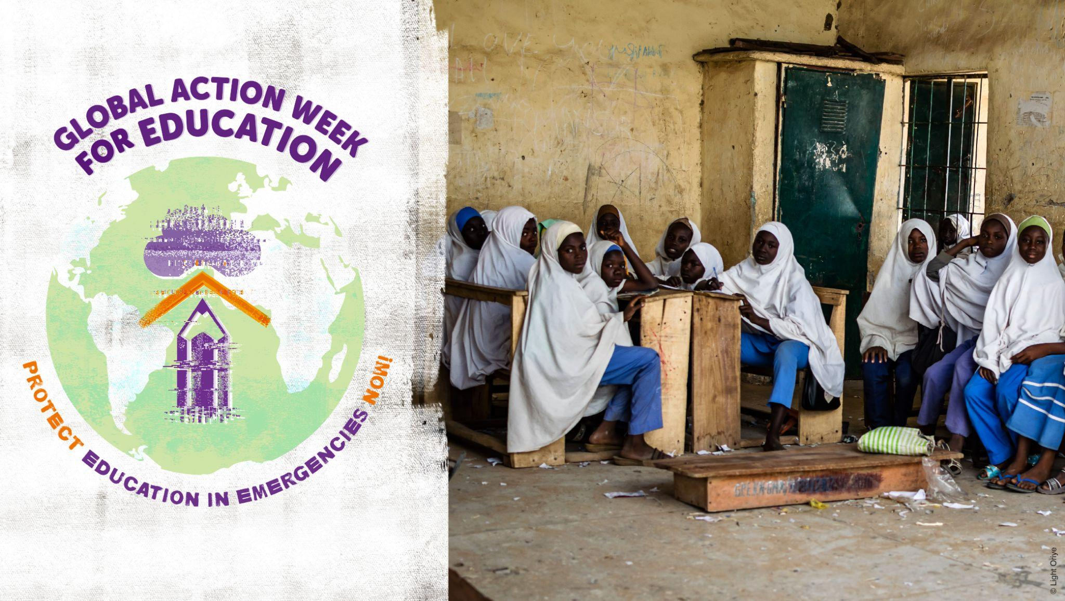
 | Short text:  In emergencies, #girls, #women and learners with disabilities face multiple & intersecting discriminations @AncefaRegional calls on @_AfricanUnion @ecowas_cedeao gvts & dvt partners to #ProtectEiENow and adopt inclusive & gender responsive planning & budgeting for #EiE. #GAWE2022  Long text:  In emergencies, #Girls, #women and learners with disabilities are disproportionately affected & face multiple and intersected discriminations @AncefaRegional calls on African governments, @_AfricanUnion @ecowas_cedeao development partners & practitioners to #ProtectEiENow & adopt an inclusive & gender responsive approach to planning & budgeting for emergency responses. #GAWE2022 | 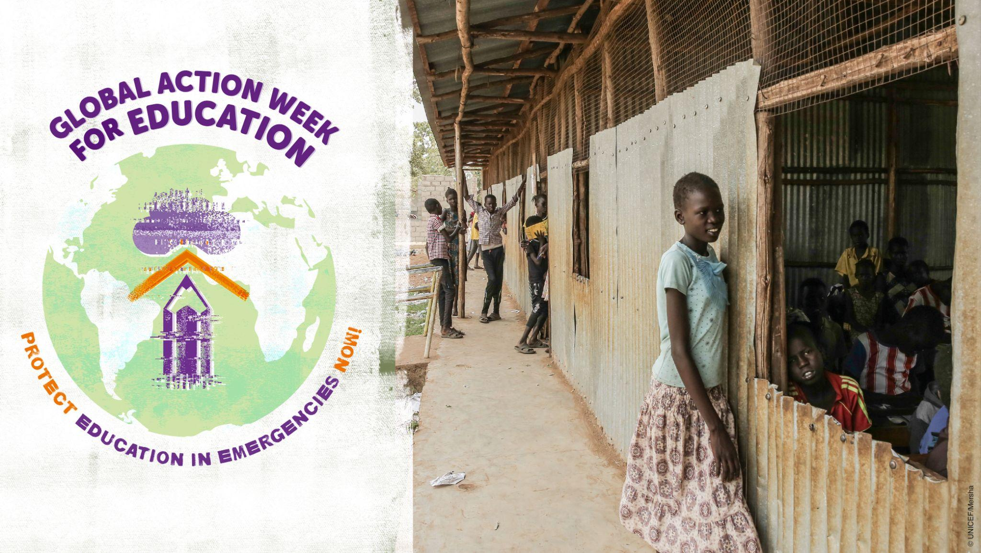
 | Africa faces multiple crises: climate disasters, #COVID19 and conflicts. @AncefaRegional calls on @_AfricanUnion @ecowas_cedeao gvts & donors to #ProtectEiENow & provide increased & sustainable funding for quality, equitable #education for all even in emergencies. #GAWE2022 | 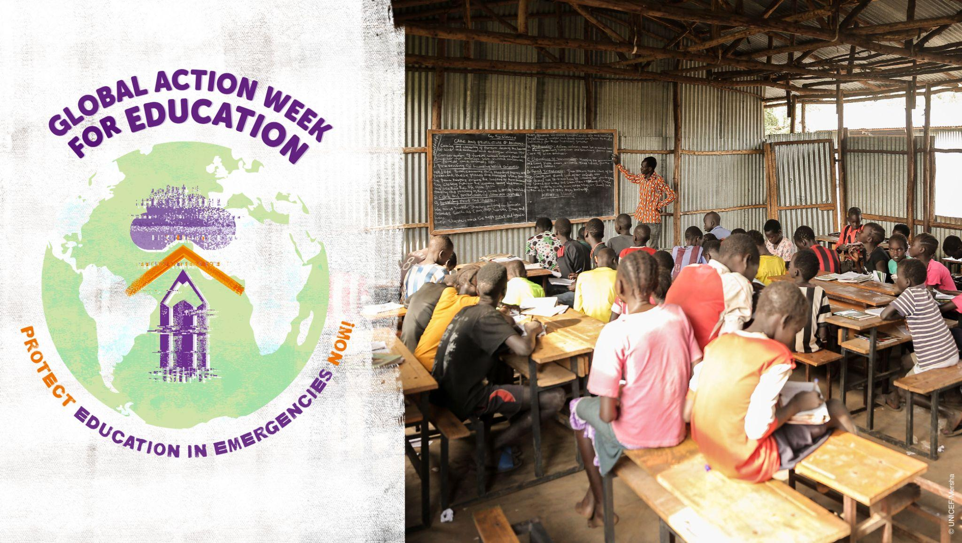
Fri 29 April | Today we focus on the global displacement crisis. Join the #GAWE2022 global culmination event: 'Equitable Access to Learning in Displacement: Taking Action Against Discrimination and Marginalisation.'  📅 29 April ⏰8:00 EST / 14:00 CET 🔗https://bit.ly/GAWEGLOBAL  #ProtectEiENow
 | The world is facing a massive and quickly-growing displacement crisis. Achieving @GlobalGoalsUN and particularly #SDG4 means being able to guarantee access to quality, inclusive #education to children and learners moving within and across borders! #ProtectEiENow #GAWE2022 | 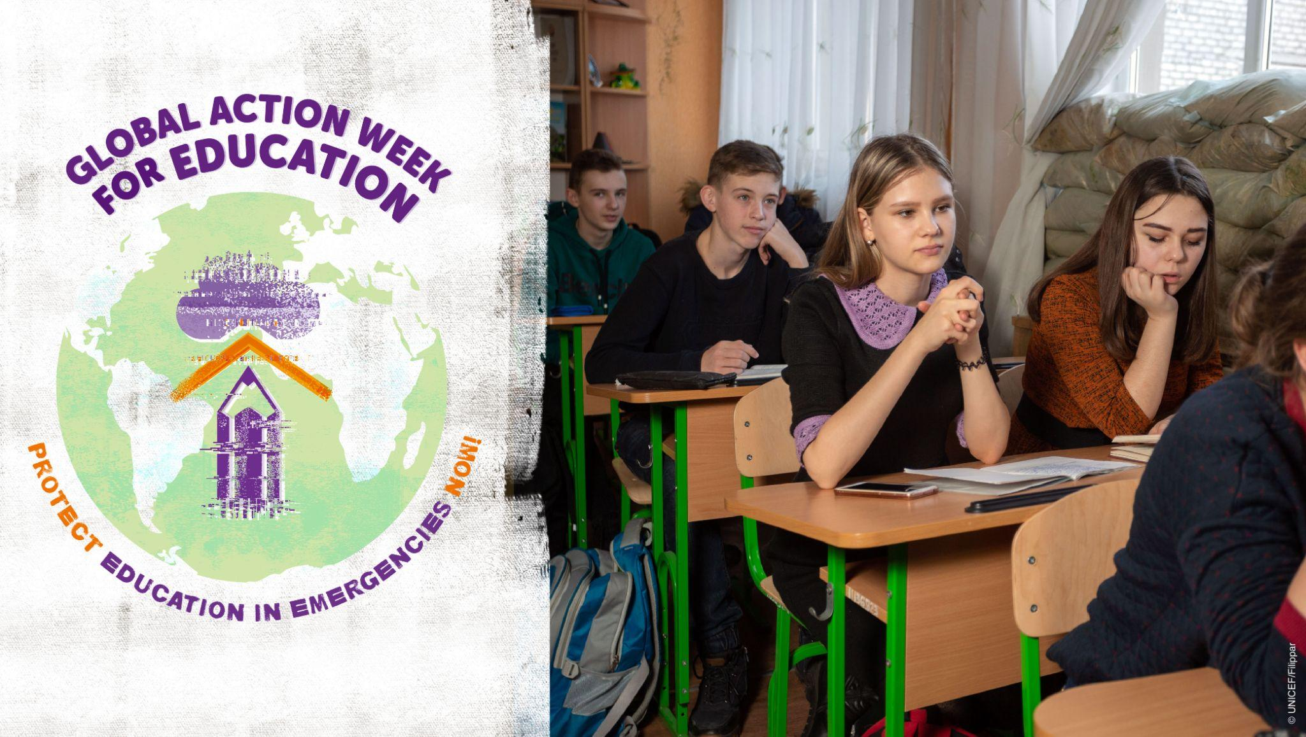
 | Crises, including those ongoing in #Ukraine, #Afghanistan, #Ethiopia, #Yemen etc have underscored the multiple & intersecting discriminations faced by refugees & IDPs that hinder access to quality, inclusive #education. Join #GAWE2022 to demand urgent action and #ProtectEiENow ! | 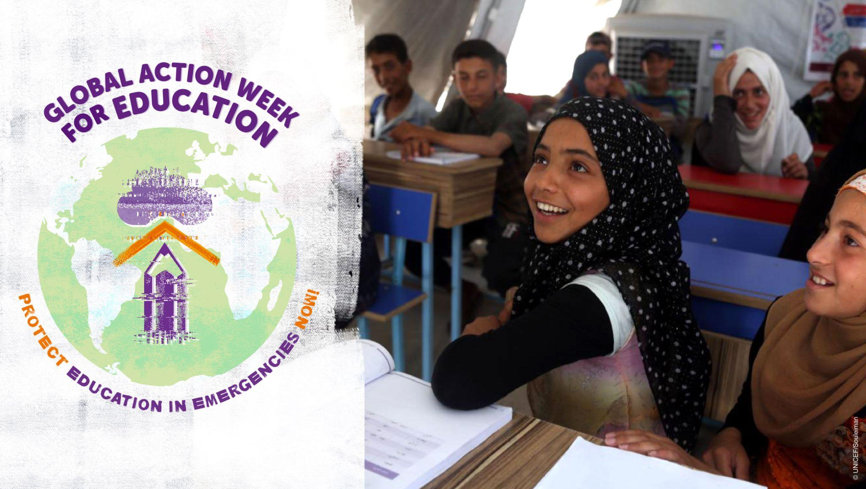
 | Today #GAWE2022 calls on donors, @G7, @WorldBank,  @IFC_org, and @UN agencies to  #ProtectEiENow & support countries that host refugees & IDPS to strengthen their national #education systems including by providing sufficient, sustainable and predictable funding for education. | 