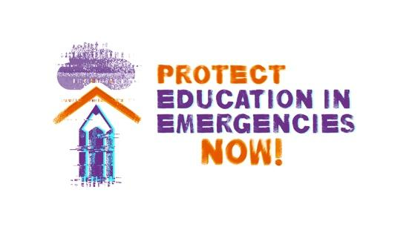
Social Media Toolkit
Protect Education in Emergencies Now!
#ProtectEiENow
Education is a basic human right. Yet even prior to COVID-19, 250 million children & youth were out of school and 800 million adults were illiterate. Conflict, climate change, disasters, public health emergencies and the forced displacement of people within and across borders are affecting a growing number of people all over the world. `In 2021, 235 million people were in need of humanitarian assistance and protection.

Emergencies have a devastating impact on the right to education of millions of people. In 2019, 127 million primary and secondary school-age children and young people living in crisis-affected countries were out of school. For the most marginalized—learners with disabilities, girls, and those from low-income households, among others—the impact is much greater.

Despite this dire situation, education remains one of the most underfunded areas of humanitarian aid, receiving just 2,4 % of total global humanitarian funding.

A generation of children and young people living in emergencies are deprived not only of their human right to quality education, but also of the protection that education provides in these contexts. In emergencies, education may be the only safe space.

THIS MUST CHANGE. Together we can PROTECT EDUCATION IN EMERGENCIES NOW!

Social media tags/mentions: Facebook: @campaignforeducation Twitter: @globaleducation Instagram: @campaignforeducation LinkedIn: @globalcampaignforeducation
 | #ProtectEiENow Key Messages | Suggested Visuals | Suggested Text Only Posts  (Square or Rectangle)
 | Conflict, #climatechange disasters, public health emergencies & forced displacement have a devastating impact on the right to education of millions of people. Join #ProtectEiENow campaign to demand change today! | 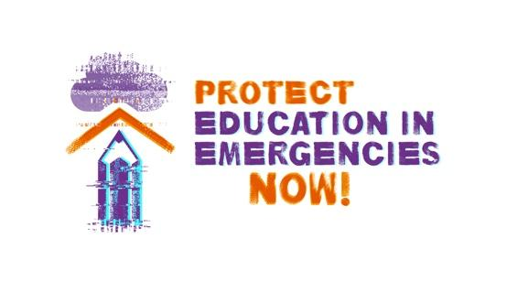 | 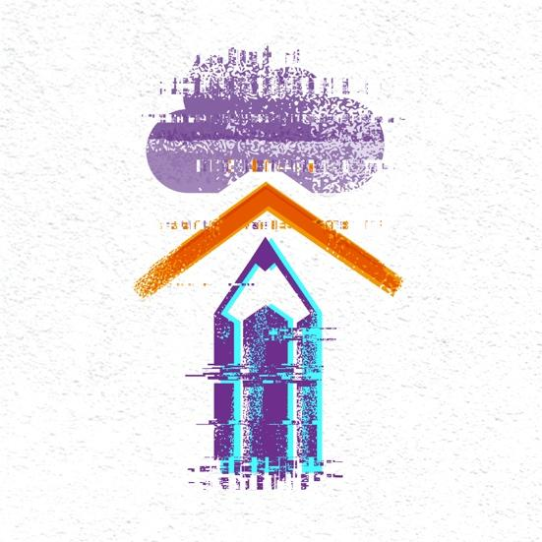
 | 127+ million children and young people living in crisis affected countries are out of school.  TOGETHER WE CAN CHANGE THIS!  Let us stand side by side as a global movement to #ProtectEiENow !  CALL TO ACTION in this SHORT FILM: 🔗https://bit.ly/3GT8aCE | FILM LINK
1 | States must guarantee the #HumanRight to quality #EducationForAll , especially in emergency contexts, by providing empowering, safe, inclusive and accessible learning environments for all learners without discrimination.  #ProtectEiENow | 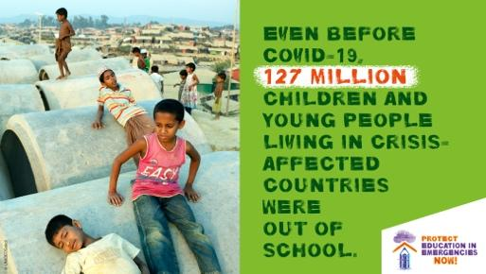 | 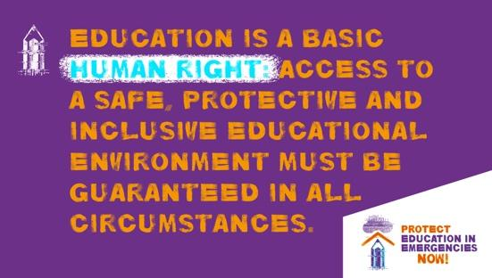
2 | The best way to #ProtectEiENow is to build resilient national education systems! States must develop and implement crisis-sensitive national #Education plans & budgets and integrate emergency preparedness measures into education sector planning. | 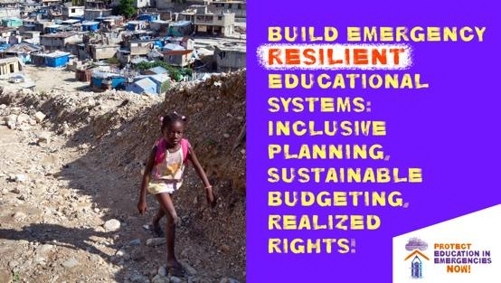 | 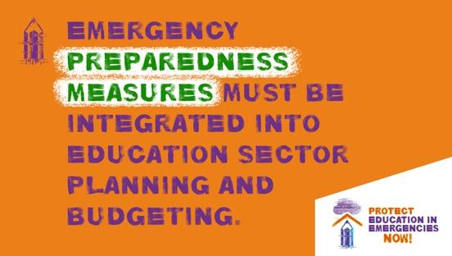
3 | All actors involved in emergency response must listen to the voices of the people affected including local civil society, teachers, children & youth groups, parents & communities & ensure their meaningful participation from design and planning to implementation. #ProtectEiENow | 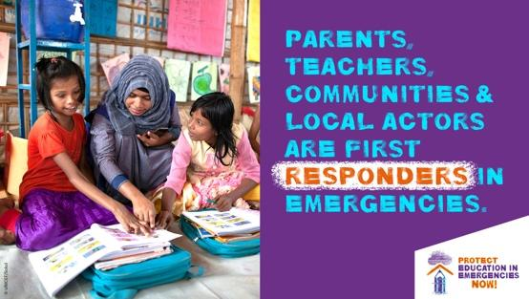 | 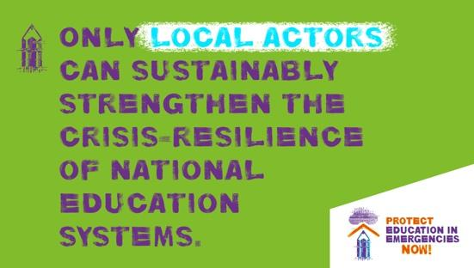
4 | We call on Donors [or insert relevant gvt/ministry handle] to #ProtectEiENow by providing sufficient, sustainable and predictable funding: allocate at least 10% of humanitarian funding to #education & support the @EduCannotWait replenishment in reaching its funding target of at least $1 billion for the period 2023-2026. | 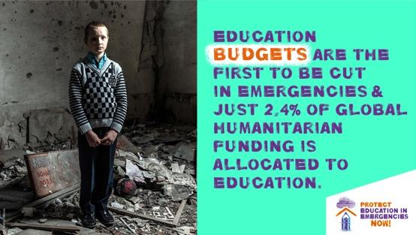 | 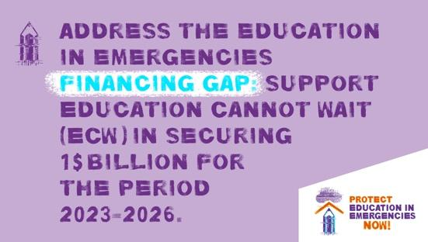
5 | Protect the #HumanRight to #Education of the 82.4+ million displaced people worldwide! Refugees, asylum seekers, returnees, stateless & internally displaced persons must be equitably and sustainably included in national education systems.  #ProtectEiENow ! | 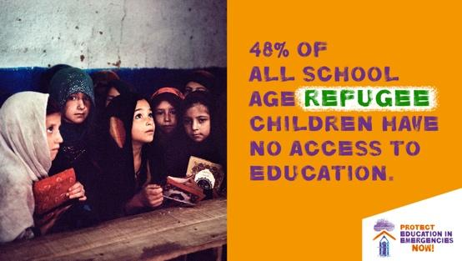 | 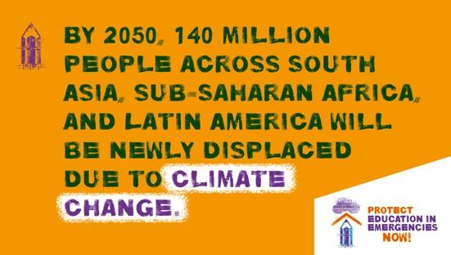
6 | More than twice as many #girls in crisis- affected contexts are out of school compared to global averages. This makes them even more likely to be subjected to violence, harassment & child marriage. Protect #girlseducation ! #ProtectEiENow ! | 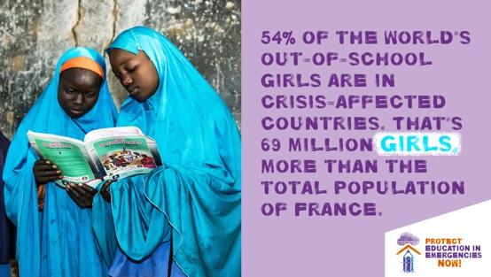 | 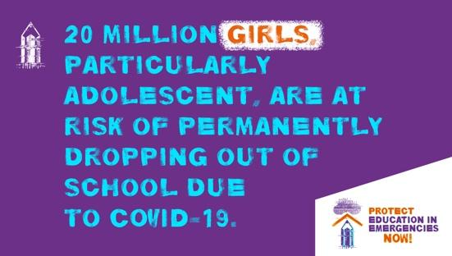
7 | #ProtectEiENow and ensure that learners with disabilities have equal opportunities to fulfill their right to education in emergency contexts. We call on all policymakers to apply an #InclusiveEducation perspective in the planning, budgeting & implementation of emergency response. | 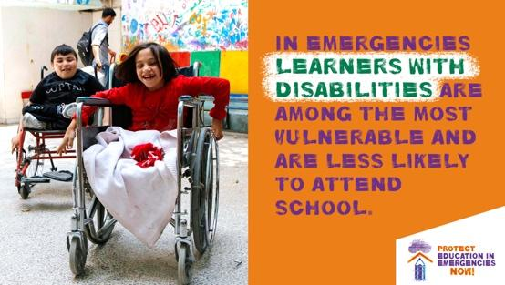 | 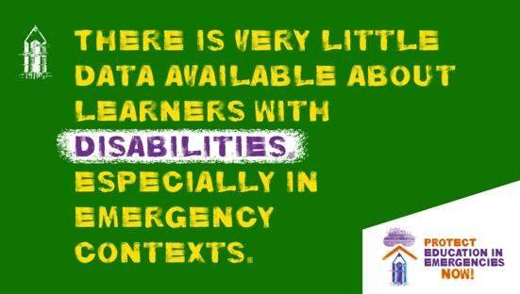
8 | Protecting the #right to #EducationForAll in emergencies requires qualified, adequately supported, safe & healthy #teachers and #educators!  #ProtectTeachers ! #ProtectEiENow ! | 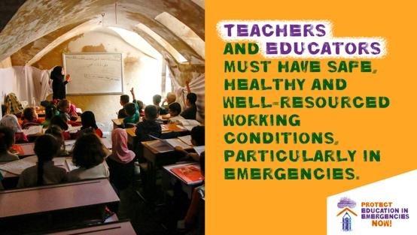 | 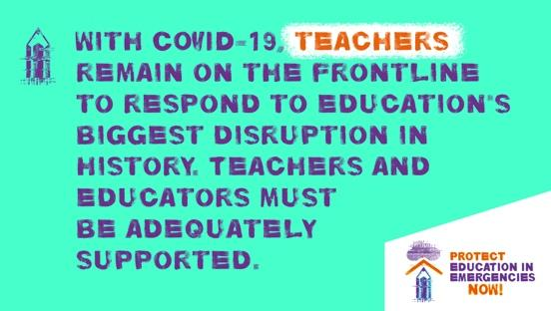
9 | Threats, attacks, & insecurity disrupt the #education of millions of learners. Targeted attacks on #education must stop! We call on all states to endorse & implement the #SafeSchoolsDeclaration & ensure that all learners and educators can learn and teach in safety. #ProtectEiENow | 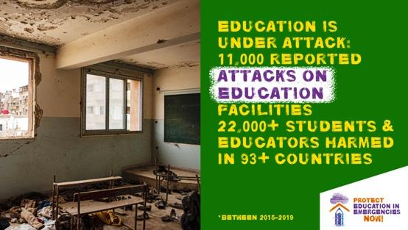 | 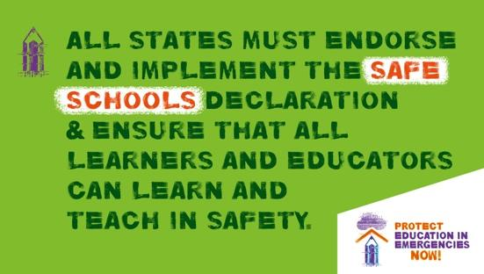
10 | #Transformative #education promotes social & emotional learning as well as critical thinking on the structural causes of crises & the ways to overcome them, putting #rights dignity & solidarity at the center. #EducationBuildsPeace #ProtectEiENow ! | 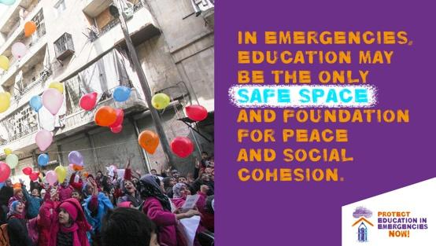 | 